NITRATE AND AMMONIUM ASSIMILATION AND TRANSAMINATION
Two metallo-proteins i.e. larger Mo-Fe-Protein and smaller Fe-protein components are involved in Nitrogen Fixation. Fe-protein interacts with ATP and Mg++ and receive electron from Ferredoxin or Flavoid oxin when it is oxidized.
Mo-Fe-Protein of nitrogenase complex combines with N2 and yields 2 molecules of NH3. This means N2 is reduced stepwise without breaking N-N bond until the final reduction and formation of NH3 is complete and 2 molecules of NH3 are released.
MECHANISM OF ELECTRON TRANSPORT
- Fe-protein (oxidized form) gets electrons from Ferredoxin (when it combines with 2H+ and yields H2) and energy from ATP. Mg++ activates this reaction.
- Electron is transferred to oxidise Mo-Fe protein which becomes reduced and Fe-Protein is oxidised. It is the reduced form of Mo-Fe protein which combines with N2 and other substrates to produce ammonia and other products with respect to substrate.
- H2 produced during this reaction is further utilized by same micro-organisms which possess hydrogenase.
- Re-utilisation of H2 increases nitrogenase activity by protecting it from inhibition of H2.
- Ammonia is further synthesized into a number of metabolic products in microbial cells. Although NH3 is not accumulated in the cell, but few species may create it, rather it is incorporated into organic forms by combining with an organic acid (α-Keto glutamic acid) to give amino acid e.g. Glutamic Acid. The NH3 may also combine with organic molecules to yield Alanine or glutamine.

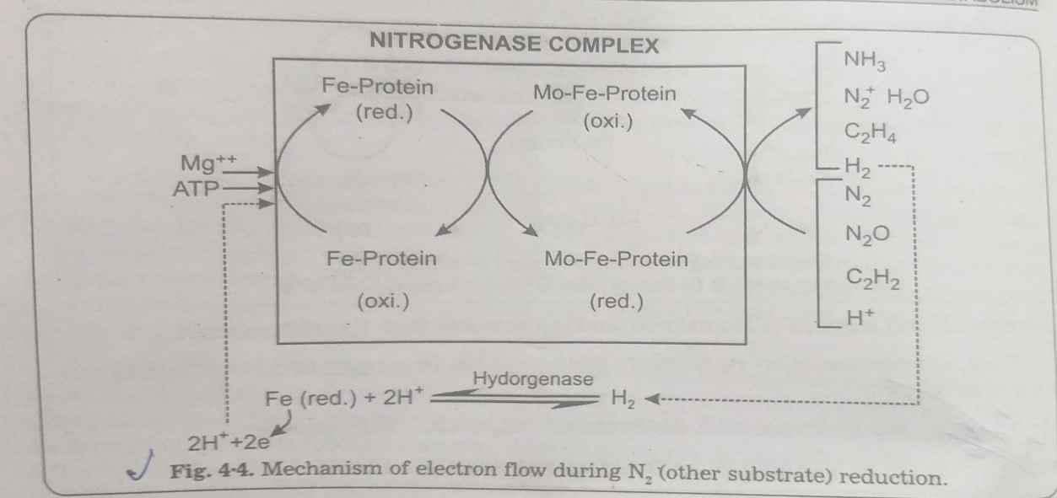

- Glutamine Synthetase (GS) catalyses the reaction of glutamic acid and NH3 and converts into glutamine.
- Glutamine combines with 2-oxoglutarate and forms 2 molecules of glutamic acid with presence of an enzyme, glutamine oxoglutarate amino transferase (GOGAT).
- Glutamic acid is the source of several metabolic products such as amino acids, nucleotides, proteins.
- The 2-oxoglutaric acid is produced by combining maltose with C02. Also maltose gives rise to glucose-6-PO4.
- Its conversion in different micro-organisms differs. In cyanobacteria, Glusose-6-PO4 is converted to Ribose-5-PO4 with an Intermediate product 6-Phosphogluconate and produces H+. In bacteria, it also differs in different genera.
In clostridium pasreurianum, pyruvic acid is produced from Glucose-6-PO4.

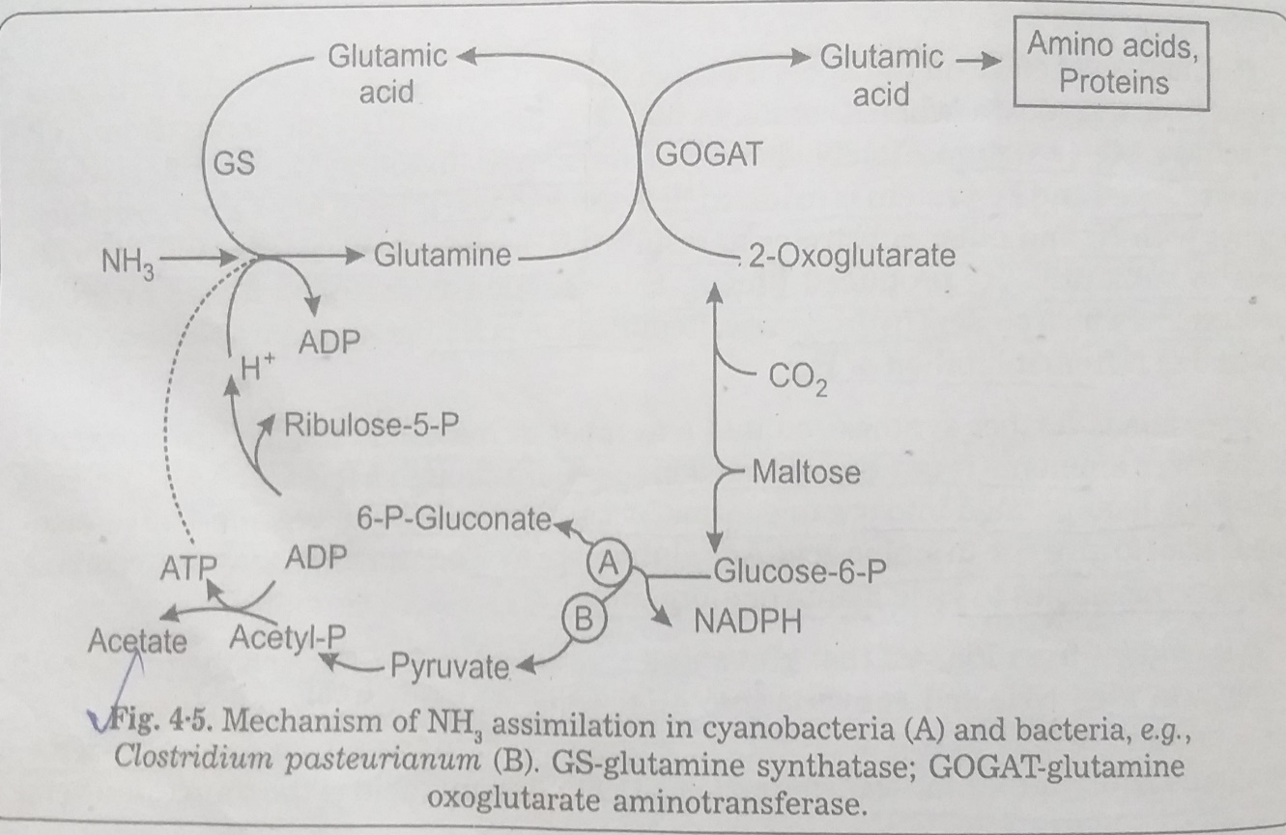

NODULE FORMATION IN LEGUMES
Nodules are small knot like structures formed on the roots of leguminous plants by the infection of nitrogen fixing bacteria- Rhizobium which live freely in the soil. These roots secrete some chemical substances Lectins (Carbohydrate containing proteins) which attract these bacteria over their surface. The Lectins are compatible to rhizobial cells only and infection produces nodules which lie between the root tip and the young root hair. The rhizobial cells enter into the host through the young root hairs.
Prior to entry, bacterial cells secrete some hormone like substance which causes deformation and curling of young root hairs and followed by the formation of tubular infection there and in the root hair cell. Finally bacterial cells enter into the infection and multiply after reaching the cortical cells and form nodules.

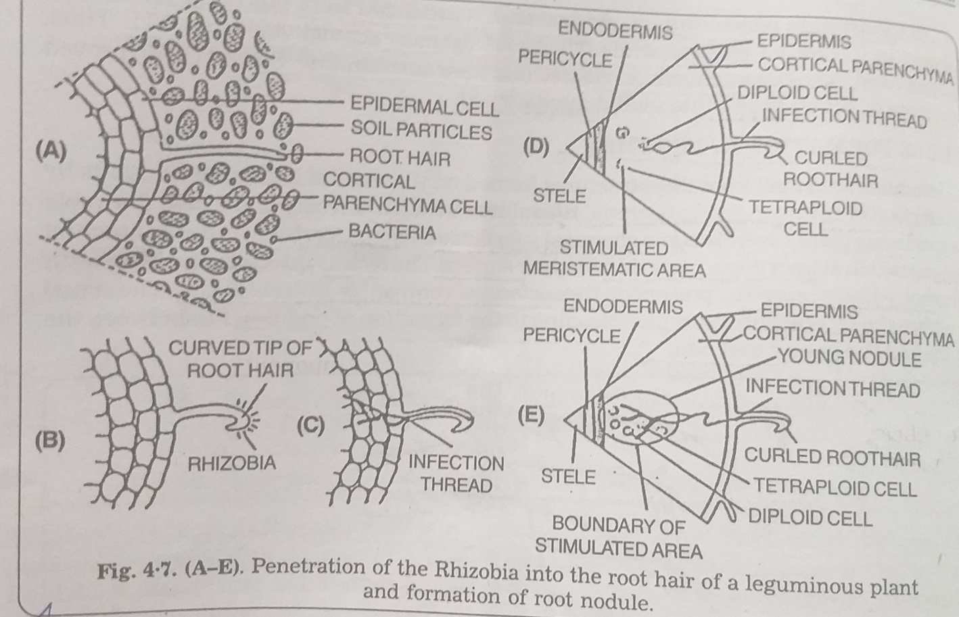

NITRATE REDUCTASE
- Nitrate Reductase is a metallo-flavo-protein complex that catalyses the reduction of nitrate to nitrite and was isolated in a highly purified form . This enzyme system includes reduced pyridine nucleotide (NADPH2 or NADH2) as an electron or Flavin Adenine Dinucleotide (FAD) and Molybdenum as prosthetic group.
- Electrons are passed from reduced NADH2 to FAD and then to oxidised molybdenum which gets reduced and passes electrons to nitrate and reduces it to nitrite.
- The enzyme nitrate Reductase is capable of utilizing whichever reductant is available, like NADPH2 in green tissues in the presence of light and NADH2 in colorless as well as green tissues in darkness. Nitrate Reductase appears only in the presence of a particular substrate. The inducer for the formation of nitrate Reductase seems to be nitrate in some systems.

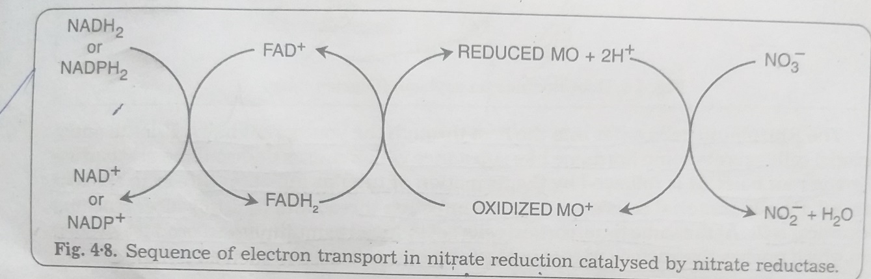

The presence of other factors such as light, Co2 and calcium are important in the formation of nitrate Reductase.

NITRITE REDUCTASE
- Nitrite Reductase is also a metallo-flavo-protein.
- It consists of the flavin protein (FAD) and molybdenum which acts as electron carriers from NADH2 to the NO3⁻
- NADH2 is the normal electron donor in some plants, other donors such as NADH2, FMNH2 and FADH2 may function accordingly.
- Intermediates between C02 and NH3 are bound to the enzyme.
- Nitrite Reductase is a single protein that catalyses reduction of NO2 to NH3 directly from a reductant of Photo-system-1.
- Nitrite reductases have been isolated from both chlorophyllous tissues where they are present in the chloroplasts and from non-photosynthetic tissues such as tomato and barley roots. The chloroplast nitrite reductase operates with reduced Ferredoxin. NADH2 or NADPH as electron donors, the reductases from non-green tissues cannot accept directly from reduced NADPH.
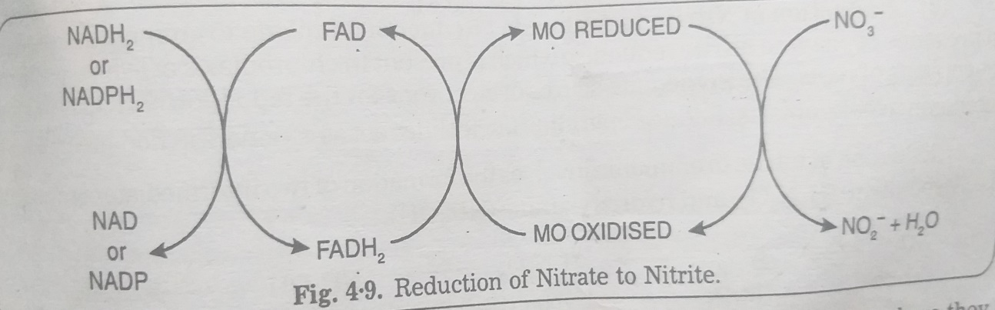
REDUCTION OF NITRATE TO AMMONIA BY PLANTS
Nitrogen constitutes 78% of the atmospheric gases and majority of plants cannot utilize this form of nitrogen directly. Only some bacteria, some blue green algae can fix atmospheric nitrogen. In Nitrate (NO3), nitrogen is taken by the plants from the soil.
Nitrogen in NO3 (Nitrate) is present in highly oxidised state while in ammonia is in reduced form. Reduction of nitrate to ammonia takes place in many steps which are mediated by specific enzymes.
At each step, 2 electrons are added. The electrons are supplied by the reduced co-enzyme-1 (NADH2) or reduced Co-enzyme –II (NADPH2).
- REDUCTION OF NITRATE(NO3⁻) TO NITRITE(NO2⁻)
- This takes place in presence of enzyme Nitrate reductase which requires reduced co-enzyme I (NADH2) or Co-enzyme (NADPH2).
- This enzyme is molybdo-flavo-protein which contains FAD as the prosthetic group with which Molybdenum is associated.
- During the reduction process, electrons are transferred from reduced co-enzymes NADH2 OR NADPH2 to FAD which gets reduced (FADH2).
- From reduced FADH2, the electrons are transferred to NO3⁻ through molybdenum so that NO2⁻ AND H₂O are formed. Nitrate reduction takes place in the roots and green leaves and nitrate reductase is present in cytosol.
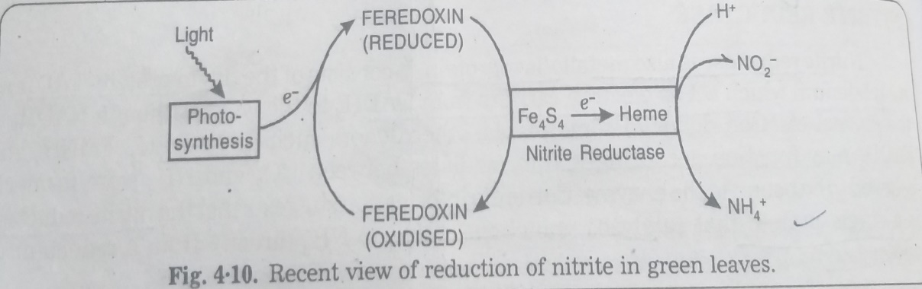

- REDUCTION OF NITRITE TO AMMONIA
- Reduction of Nitrite to ammonia takes place in the presence of enzyme nitrite reductase which is present in chloroplasts of leaves and in the leucoplasts of roots.
- The source of electrons for reduction of NO2- is reduced Ferredoxin in Chloroplasts.
- Reduced Pyridine Nucleotides act as electron donors in non-green tissues.

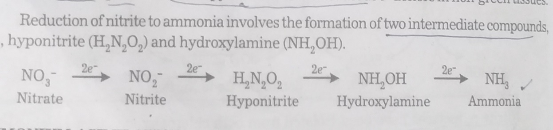
AMMONIUM ASSIMILATION
Inorganic nitrogen in the form of NH3 or NH4+ produced as a result of reduction of nitrates or biological nitrogen fixation are obtained from soil, is converted into amino acid. This is called ammonium assimilation. Absorption of nitrate by roots from soil is a carrier mediated active process. Reduction of nitrate to ammonia is called Ammonium Assimilation. This occurs in following steps:
- First step is the conversion of nitrate to nitrite by the enzyme nitrate reductase.
- The second step is the reduction of nitrite to ammonium ions by the enzyme nitrite reductase.
NO₂ + 8e⁻ + 8H⁺ NH₄⁺ + 2H₂O
The ammonia or ammonium is used in the synthesis of amino acids and amides as described below
- SYNTHESIS OF AMINO ACIDS : There are 2 ways
- Reductive amination: Glutamic acid is synthesized by a reaction between ammonia (from reduction of nitrates) and α keto glutaric acid (kreb’s cycle). The reaction requires hydrogen donor and co enzyme I and catalyzed by an enzyme glutamic acid dehydrogenase.
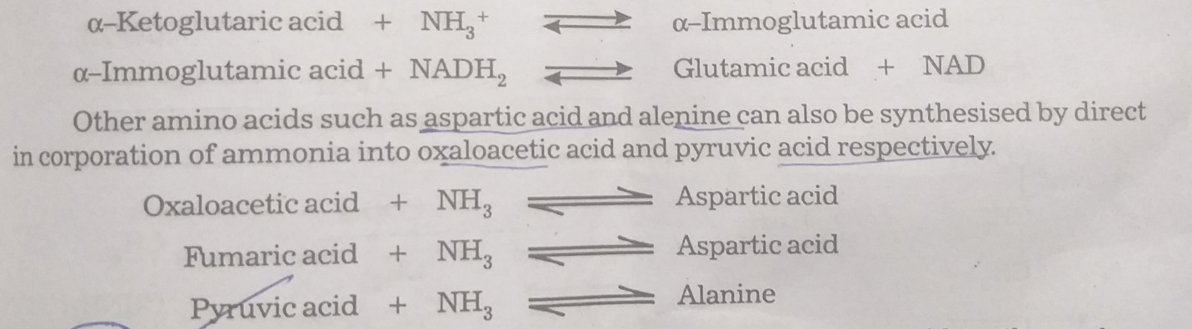
- Transamination: The transfer of amino group of an amino acid to the other carbon skeleton is called Transamination. Transamination is central to amino acid metabolism and it is one of the steps in the biosynthesis and degradation of nearly all amino acids. Transamination reactions are catalysed by transaminases and co-enzyme pyridoxalphosphate. There are 2 chemical reactions:
- Reaction between amino acid and alpha-keto acid: The amino group is transferred from the amino acid to the keto acid. This reaction is catalysed by enzymes called Transaminases or amino-transferases. This process is an important step in the synthesis of some non-essential amino acids (not supplied by diet). The products are alanine, aspartate.
- Involving nucleophilic substitution of one amine or amide anion or an amine or ammonium salt. For e.g., the attack of a primary amine by a primary amide anion can be used to prepare secondary amines.
SOME TRANSAMINATION REACTIONS ARE:
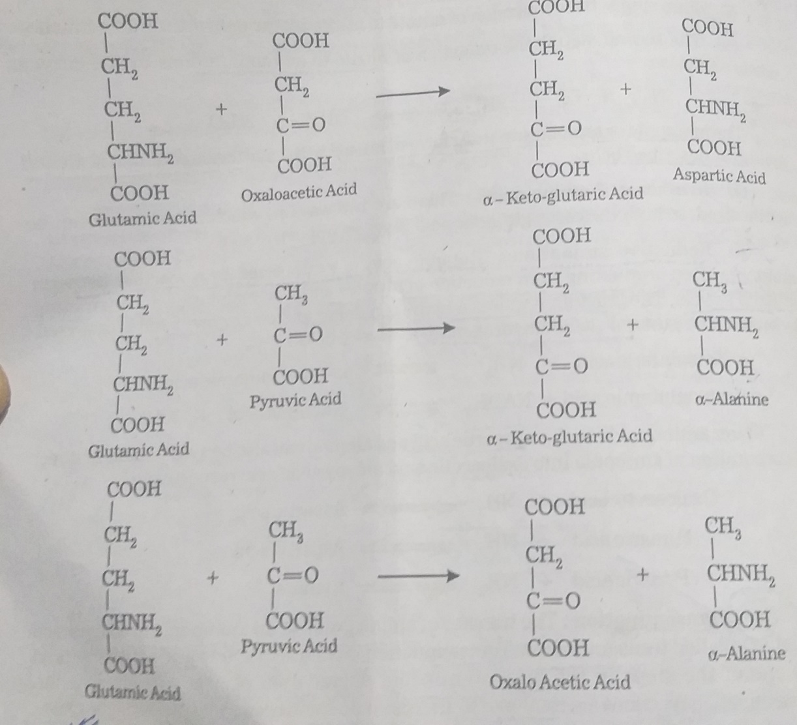

- FORMATION OF AMIDES: Amount of ammonia available to a plant is in excess of its immediate requirements. This ammonia is accumulated primarily in the form of amides such as glutamine, asparagine which are actually glutamic acid and aspartic acid with an extra NH2 group attached to an acidic group. ATP is required for the formation of these amides.
GLUTAMIC ACID + NH3 GLUTAMINE
ASPARTIC ACID + NH3 ASPARAGINE
As free ammonia is somewhat poisonous, amides formation may be regarded as a protective mechanism by which excess nitrogen is stored in an innocuous form. Amides may also act as a means of trans locating NH2 groups during the mobilization of storage protein for growth.

